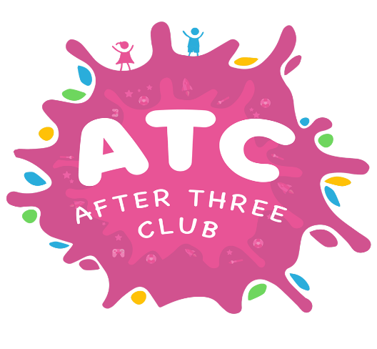**Dear Parents/carers,**

Welcome back to ATC after a long and unexpected break.

Firstly I would like to say a “MASSIVE” Thank you to all the parents who have continued to pay their fees to support me during this pandemic and have enabled me to stay afloat the last 6 months and be able to re-open.

**Website**

Please take time to look at the new ATC website. I will use the

noticeboard section to post the termly newsletters and any important

or emergency information.

I will txt you to let you know when I post anything, I need you to see.

The new ATC COVID19 risk assessment is on the website, this will advise you how we are going to be running our after-school sessions for the foreseeable future. The school are fully supportive of the new structure, policies & procedures.

It will be all new for the staff and children and will take some adjustment, but we are confident that we can keep your child safe and give them an enjoyable experience at ATC.

**Year group structure**

Each year group will be supervised by a member of staff and they will be kept in their year group bubbles on tables in a section of the hall.

We will aim to get the children outside to play as much as possible.

Each staff member will take their year group register for the day and they will also sign your child out as they hand them over to you.



**Snacks and drinks**

Simpler snacks will be served at their year group tables. Children will need to have a drinks bottle with them, they will be able to fill them up during snack time and then they will keep these with them during the session.

If you do not send your child in with a drinks bottle and your child needs a drink, we will provide them with a bottle of water at a cost of £1.00 which we will invoice you for.

**Collecting your child/children**



Due to the COVID19 situation you will not be able to access the hall to collect your children. Please ring the doorbell and we will bring your child to the door. Please keep the 2-metre distance outside while you wait to collect your child.



**Access to the school**

We will not be able to allow you access to the school for any reason. If you need access you will need to go to the school office.

**Restricted numbers**

The school have made the decision to restrict my numbers and have capped them at 60 per day. After the impact of lockdown and early closure of the school this will put financial pressure on the club so I am hoping this will be reviewed once we get up and going.